BUDO JUNIOR SCHOOL
REMEDIAL WORK FOR TERM 1 2020 - SET TWO
LITERACY I – PRIMARY TWO

Name : __________________________________________
Stream : ______________ Date:________________

SECTION A:
1. Who heads a family?
__________________________________________________________
2. State any one thing found in your classroom.
__________________________________________________________
3. How many eyes do you have?
__________________________________________________________
4. Who heads a school?
__________________________________________________________
5. Mention one thing we use to clean the body.
__________________________________________________________
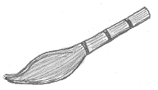
6. Name this object.
_____________________________________
7. State one way of how we can keep the school compound clean.
__________________________________________________________
8. Why do we need chalk at school?
__________________________________________________________
9. State your school motto.
__________________________________________________________
10. Why do we boil water for drinking?
__________________________________________________________
11. Draw and name one building material.

__________________________________________________________
12. Which school symbol helps school children to look smart?
__________________________________________________________
13. Circle one common disease.
housefly malaria tsetse fly

14. What food value do we get in the body when we eat eggs and fish?
__________________________________________________________
15. How many legs has a person?
__________________________________________________________
16. Which sense organ helps people to know that there is no sugar in the tea?
__________________________________________________________
17. Give an example of food that gives us proteins.
__________________________________________________________
18. Where do we keep our books at school?
__________________________________________________________
19. What must be done after visiting the toilet?
__________________________________________________________
20. Mention one language spoken in your community.
__________________________________________________________

SECTION B:
21. Match the body parts to their functions.
ears walking
eyes tasting
legs chewing
tongue hearing
teeth seeing

22. Name these means of transport
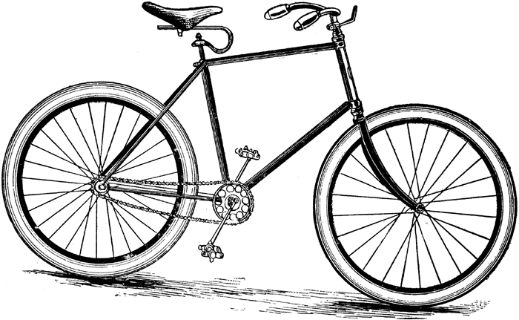
________________ _________________
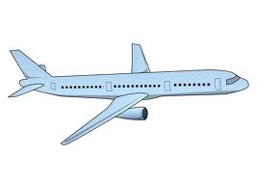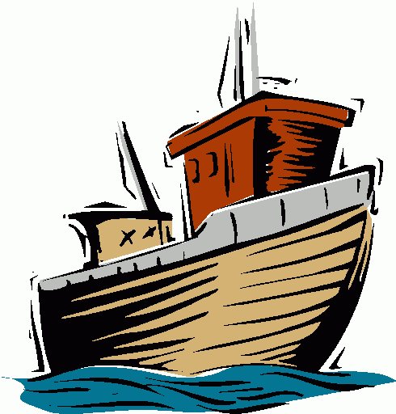
___________________ _________________

23. Use the given words to fill in;
Wakiso , family , balance diet , neighbour , germs

a. A person who stays near you is your ________________________.
b. In which district is your school found? _____________________.
c. a meal containing all the food values is a __________________.
d. What do we call the small living things that cause disease?
__________________
e. A ______________is a group of people related by blood or by
marriage.
24. Draw these family members.
father | mother | grandmother

b. State one role of a mother at home.
__________________________________________________________

25. Write the places of work for these people in our community.
A teacher works at ___________________
A shopkeeper works in ___________________
A doctor works in a ____________________
A farmer works in a ___________________

26. Match the garden tools to their uses.

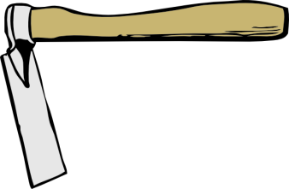 Collecting rubbish
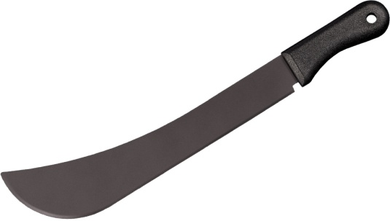 Putting in rubbish
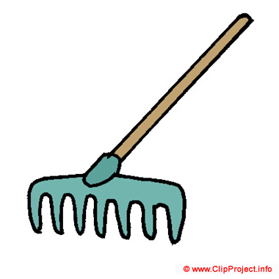 Digging

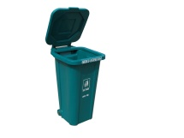 Cutting small trees
27. Give any 3 building materials used to build your school.
_______________ _______________ _____________
b. Name these types of houses.

___________________ _______________

28. Write COVID-19 in full.
_________________________________________________________
b) Mention one sign of COVID-19?
__________________________________________________________
c) How can we control spread of COVID-19 (Give two)
__________________________________________________________

29. Circle the cultural practices in your community.
family , marriage , grandfather
circumcision , naming children , burial
sanitation , introduction , blackboard

30. Put the food in their correct classes of food.
(yams , eggs , cassava , mangoes , fish, pineapples)
carbohydrates | proteins | vitamins
__________________ | ____________________ | __________________

31. State any three people found at school.
(i)____________________ (ii)_____________________
(iii)____________________
b) Who types office documents and exams at school?
__________________________________________________________

32. Match correctly:
kitchen children learn from there.
sickbay where school books are kept.
classrooms food is prepared from there.
library children get treatment from there.

b. Name the place where children at school ease themselves from?
__________________________________________________________

33. Write Yes / No.
a. A teacher teaches children at school. ________________
b. A tsetse fly spreads a disease called sleeping sickness.
______________
c. A security guard treats sick people at school. _____________
d. The Imam leads prayers in a mosque. ______________
e. Meat is an example of food in vitamins. ______________

